Exercise

Q1

Q2

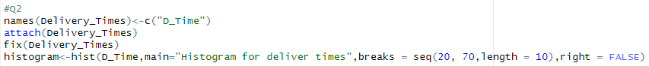

#Q3

Most of the data is at the low end, forming a peak on the left, and a few high values stretch the graph out to the right.

#Q4

